

PROPOSAL DOCUMENT

Exchange Manual Setup

28 September 2019
© Sautech (Pty) Ltd. http://www.sautech.net

INTRODUCTION

The purpose of this document is to provide a complete step-by-step installation manual to configure your online hosted exchange profile. After all procedures in this document is followed completely, you will be able to connect to your new hosted exchange account using Microsoft Office 2003 and above.

Outlook setup

This procedure will help you configure your Microsoft outlook to be able to connect to the exchange server:

- Click on Start -> control panel, once opened , double click the “Mail” icon

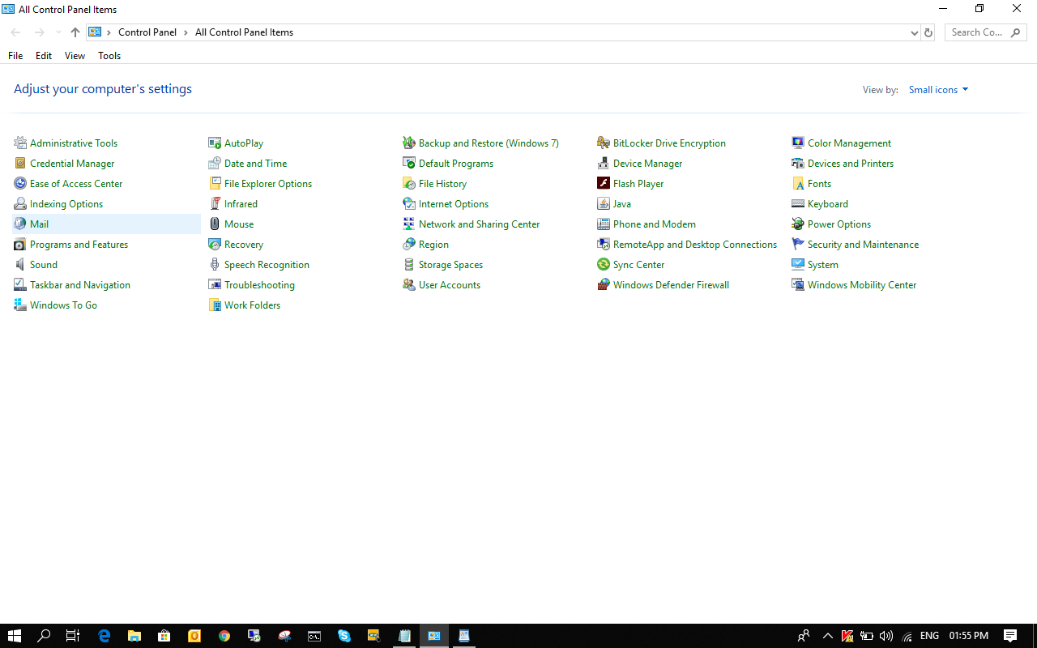

- Click on “Show Profiles”

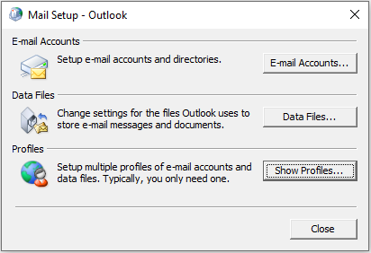

- Click on “Add”

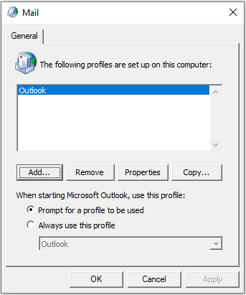

Make sure “prompt for a profile to be used” is selected (When we finish this process, and start outlook, you can select your old email or the newly created Exchange profile)

- Type a name in the profile window “example: “New Exchange” and click on “ok”

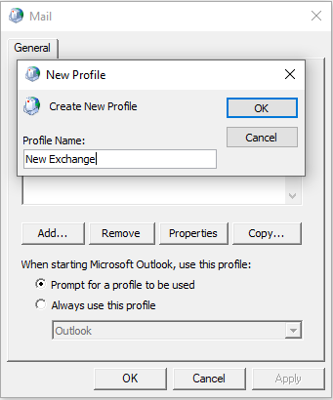

- Select the Manually configure tick box, and click “next”

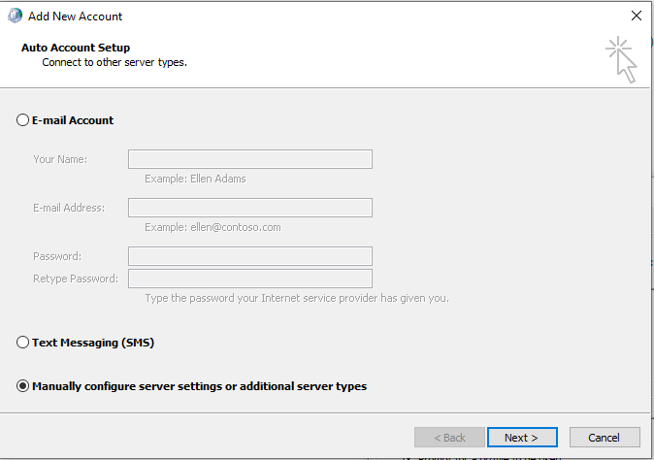

- Select “Microsoft Exchange” select “next”

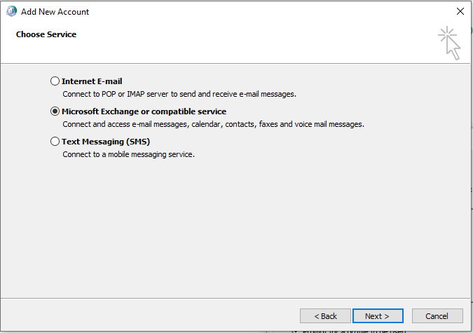

- In the server window type: exchange2016c.onlinehosting.isp
- In the User Name window type in your full Email Address
- Click on More Settings

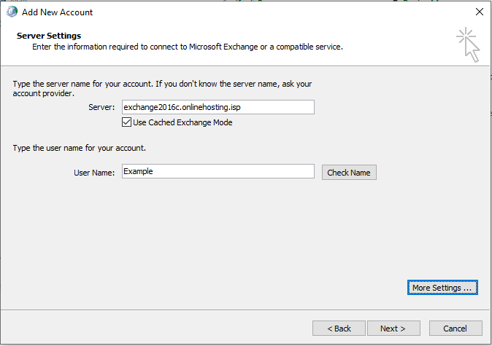

Go to the Connection Tab - Tick “Connect to Microsoft Exchange using HTTP” then click on “Exchange Proxy Settings”

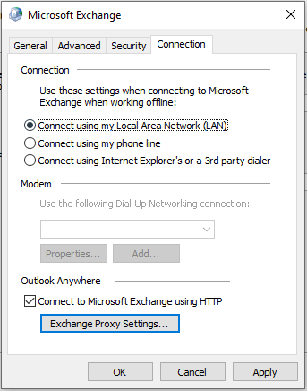

- In the “Use this URL to connect to my proxy server for Exchange” window type: exchange.onlinehosting.co.za

- Make a tick next to “Only connect to proxy server that have the principle name in their certificate” and type in the window: msstd:exchange.onlinehosting.co.za

- Tick: On fast network, connect using HTTP first, then connect using TCP/IP box

- Tick: On Slow network, connect using HTTP first, then connect using TCP/IP box.

- Under Use this authentication when connecting to my proxy server for Exchange: Select “Basic Authentication”

- Click on “OK”

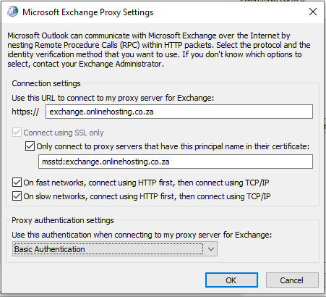

- Click on Ok, Ok again, Next then Finish

You Are Done!

When you open Outlook for the first time, the following logon information box will be displayed.
Enter your full e-mail address and password supplied. Tick the “Remember my credentials” box.

